EXPT NO:5A
DATA VISUALIZATION USING MATPLOTLIB
– PLAYER DATA
Aim:
To visualize dataset features and distributions using line charts, bar charts, pie charts, histograms, scatter plots, and box plots using Matplotlib.
Algorithm:
ALGORITHM 1: LINE CHART
Objective: To visualize the height of different players.
Steps
1. Load the player dataset.
2. Select the Player Name and Height columns.
3. Plot the player height using a line chart.
4. Add title and axis labels.
5. Display the graph.
Interpretation
The line chart shows how player height varies across different players and helps identify the height pattern.
# Program 1: Line Chart
plt.plot(player_names, height)
plt.title("Player Height")
plt.xlabel("Players")
plt.ylabel("Height")
plt.show()
Output:
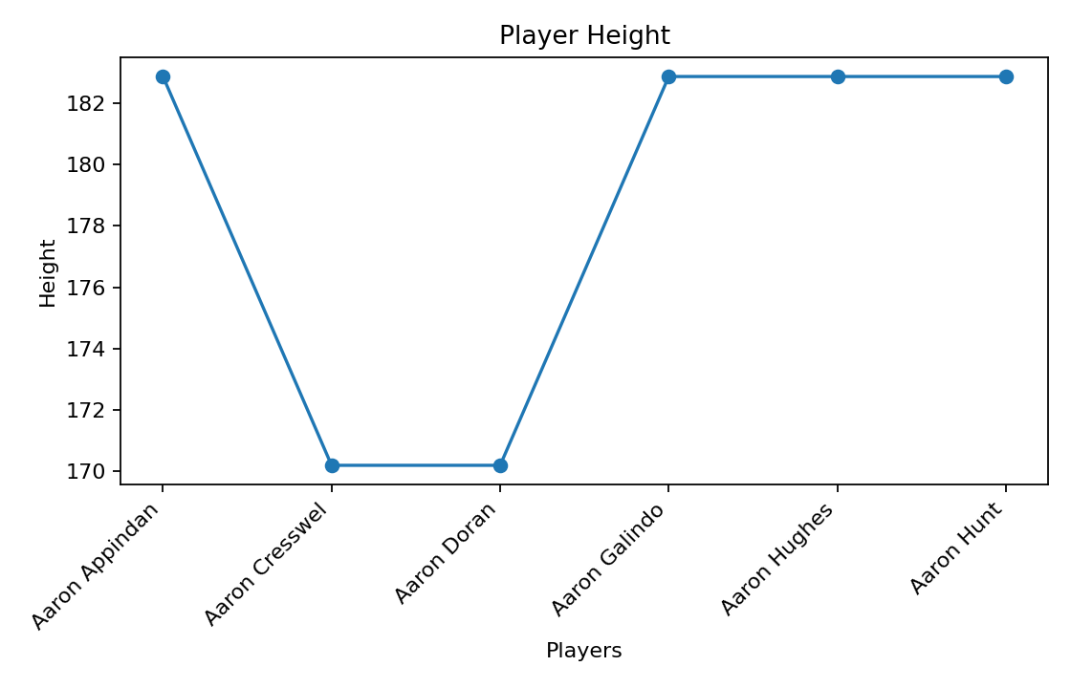

ALGORITHM 2: BAR CHART
Objective: To compare the height of different players.
Steps
1. Select the Player Name and Height columns.
2. Create a bar chart using the player height values.
3. Add title and axis labels.
4. Display the chart.
Interpretation
The bar chart helps compare the height values across different players.
# Program 2: Bar Chart
plt.bar(player_names, height)
plt.title("Player Height")
plt.xlabel("Players")
plt.ylabel("Height")
plt.show()
Output:
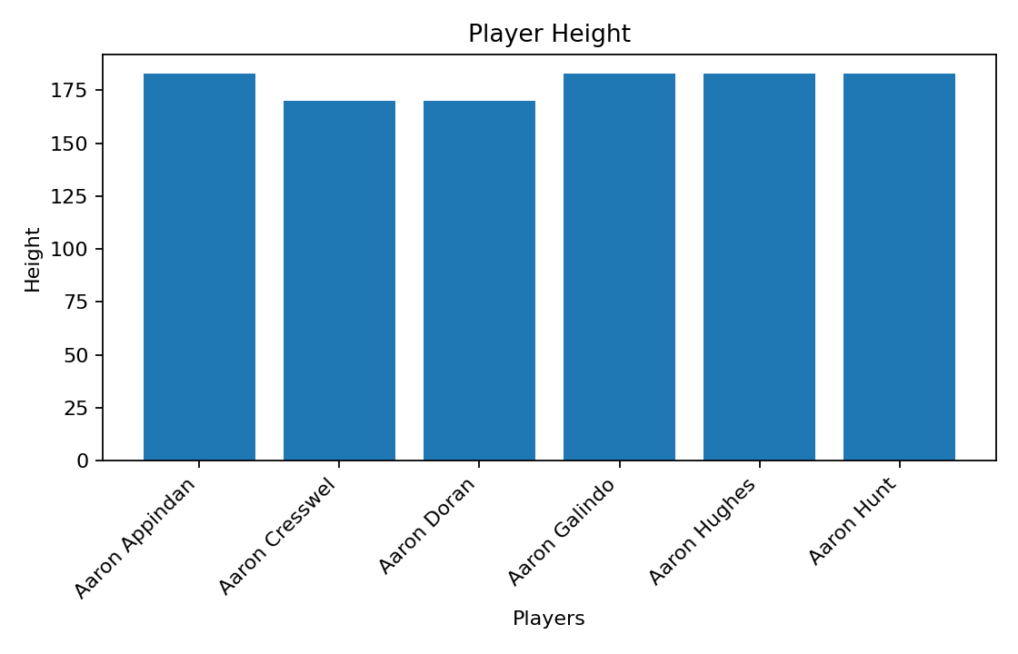

ALGORITHM 3: PIE CHART
Objective: To visualize the distribution of player height.
Steps
1. Select the height values.
2. Create a pie chart using the height values.
3. Display percentage labels.
4. Add a suitable title.
5. Display the chart.
Interpretation
The pie chart shows the percentage contribution of each player to the total height of the selected players.
# Program 3: Pie Chart
plt.pie(height, labels=player_names, autopct="%1.1f%%")
plt.title("Player Height Distribution")
plt.show()
Output:
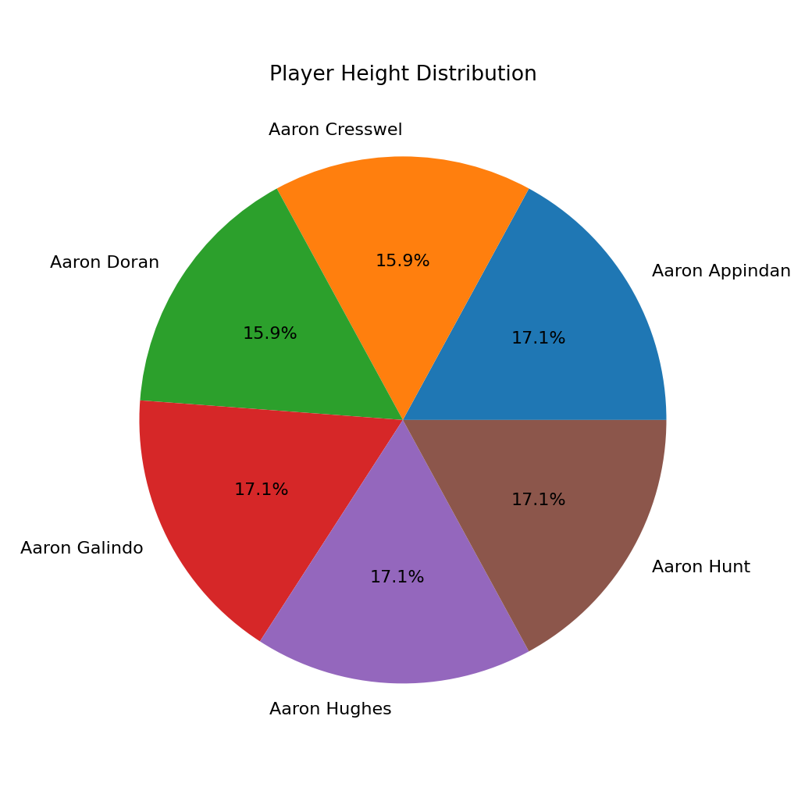

ALGORITHM 4: HISTOGRAM
Objective: To visualize the distribution of player height values.
Steps
1. Select the Height column.
2. Divide the height values into bins.
3. Create a histogram.
4. Add title and axis labels.
5. Display the histogram.
Interpretation
The histogram shows the frequency distribution of the player height values.
# Program 4: Histogram
plt.hist(height, bins=10)
plt.title("Player Height Distribution")
plt.xlabel("Height")
plt.ylabel("Frequency")
plt.show()
Output:
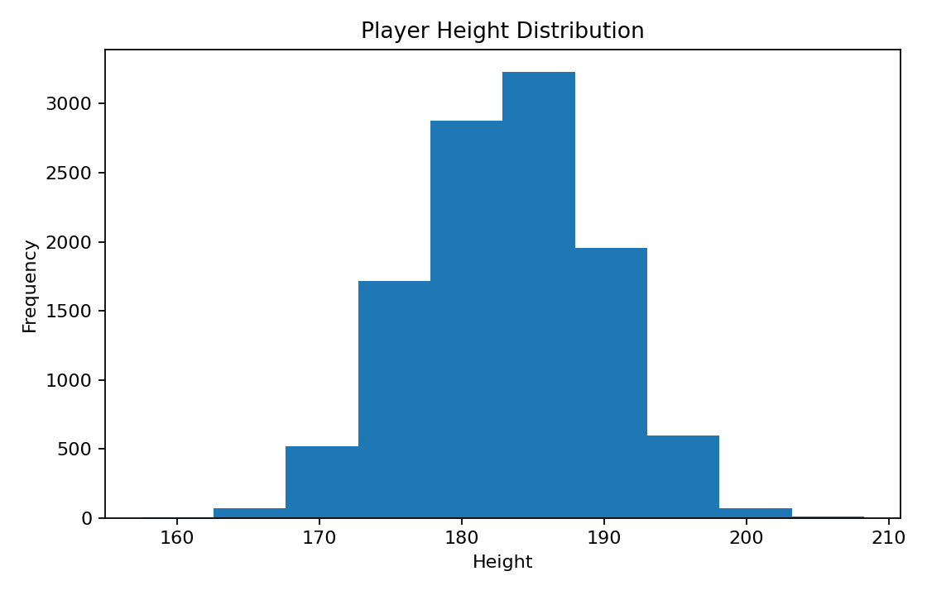

ALGORITHM 5: SCATTER PLOT
Objective: To visualize the relationship between player height and weight.
Steps
1. Select Height as the X-axis variable.
2. Select Weight as the Y-axis variable.
3. Create a scatter plot.
4. Add title and axis labels.
5. Display the graph.
Interpretation
The scatter plot shows the relationship between player height and weight.
# Program 5: Scatter Plot
plt.scatter(height, weight)
plt.xlabel("Height")
plt.ylabel("Weight")
plt.title("Player Height vs Weight")
plt.show()
Output:
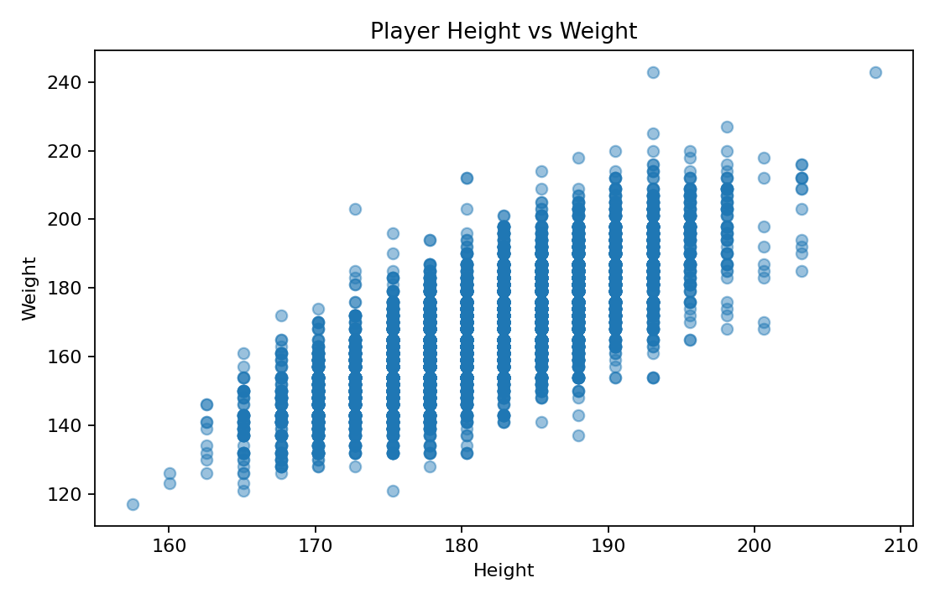

ALGORITHM 6: BOX PLOT
Objective: To visualize the distribution of player weight.
Steps
1. Select the Weight column.
2. Create a box plot.
3. Add a suitable title and axis label.
4. Display the plot.
Interpretation
The box plot shows the distribution of player weight values and helps identify possible outliers.
# Program 6: Box Plot
plt.boxplot(weight)
plt.title("Player Weight Box Plot")
plt.ylabel("Weight")
plt.show()
Output:
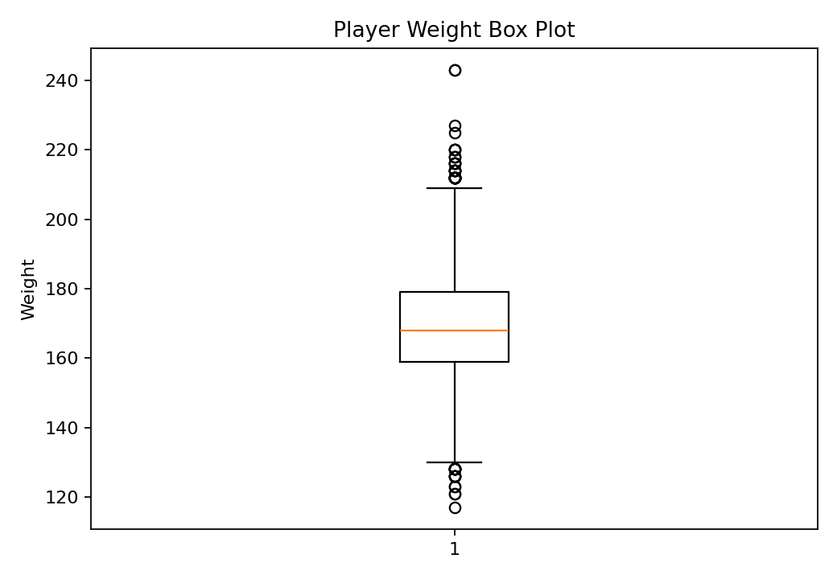

ALGORITHM 7: MULTIPLE LINE CHARTS
Objective: To compare height and weight across different players.
Steps
1. Store the weight values.
2. Plot the height values using a line chart.
3. Plot the weight values using another line chart.
4. Add title, axis labels and legend.
5. Display the graph.
Interpretation
The multiple line chart compares the height and weight values across different players.
# Program 7: Multiple Line Charts
plt.plot(player_names, height, label="Height")
plt.plot(player_names, weight, label="Weight")
plt.title("Player Height and Weight")
plt.xlabel("Players")
plt.ylabel("Value")
plt.legend()
plt.show()
Output:
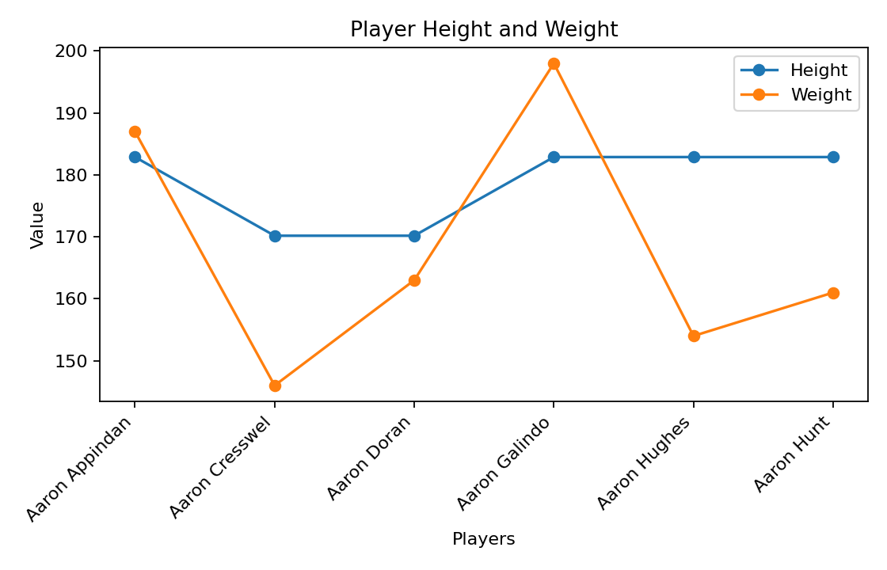
Result:
The Player dataset was successfully visualized using line, bar, pie, histogram, scatter, box, and multiple line charts. The graphs helped to understand player height and weight distributions and their relationship.

EXPT NO:5B
DATA VISUALIZATION
AIM:
To visualize the Player dataset using Python and create different charts to understand player height, weight distribution, and identify important patterns.
PROCEDURE:
1. Start the program.
2. Import Pandas, Matplotlib, and Seaborn libraries.
3. Load the Player CSV dataset.
4. Display the first few records using head().
5. Identify the numerical columns using select_dtypes().
6. Create a bar chart to compare the players based on weight.
7. Create a line chart to analyze the weight of the first 20 players.
8. Create a pie chart to show the weight share of the top 10 players.
9. Create a box plot to identify the distribution and outliers in player weight.
10. Create a histogram to observe the frequency distribution of player weight.
11. Add suitable titles, axis labels, legends, and grid lines.
12. Display all the visualizations.
13. Analyze the graphs and identify important patterns.
14. Stop the program.
CODE:
import pandas as pd
import matplotlib.pyplot as plt
import seaborn as sns
# Load Player dataset
df = pd.read_csv("Player.csv")
# Display dataset
print("Dataset Preview:")
display(df.head())
# Select numerical columns
num_cols = df.select_dtypes(include="number").columns
print("\nNumerical columns:")
print(num_cols.tolist())
# 1. BAR CHART
top10 = df.sort_values(
"weight",
ascending=False
).head(10)
plt.figure(figsize=(10,5))
plt.bar(
top10["player_name"],
top10["weight"]
)
plt.title("Player Dataset - Bar Chart")
plt.xlabel("Player")
plt.ylabel("Weight")
plt.xticks(rotation=45, ha="right")
plt.tight_layout()
plt.show()
# 2. LINE CHART
first20 = df.head(20)
plt.figure(figsize=(9,5))
plt.plot(
range(1, len(first20) + 1),
first20["weight"],
marker="o"
)
plt.title("Player Dataset - Line Chart")
plt.xlabel("Player Record")
plt.ylabel("Weight")
plt.grid()
plt.tight_layout()
plt.show()
# 3. PIE CHART
plt.figure(figsize=(7,7))
plt.pie(
top10["weight"],
labels=top10["player_name"],
autopct="%1.1f%%"
)
plt.title("Player Dataset - Top 10 Weight Share")
plt.tight_layout()
plt.show()
# 4. BOX PLOT
plt.figure(figsize=(8,5))
sns.boxplot(y=df["weight"])
plt.title("Player Dataset - Box Plot")
plt.ylabel("Weight")
plt.tight_layout()
plt.show()
# 5. HISTOGRAM
plt.figure(figsize=(8,5))
plt.hist(
df["weight"],
bins=15
)
plt.title("Player Dataset - Histogram")
plt.xlabel("Weight")
plt.ylabel("Frequency")
plt.tight_layout()
plt.show()

Output:
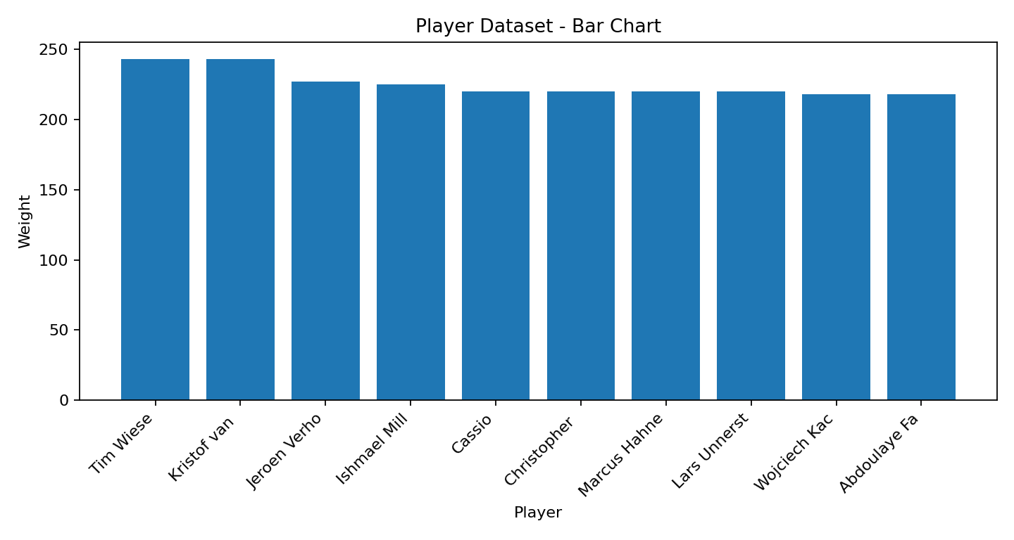
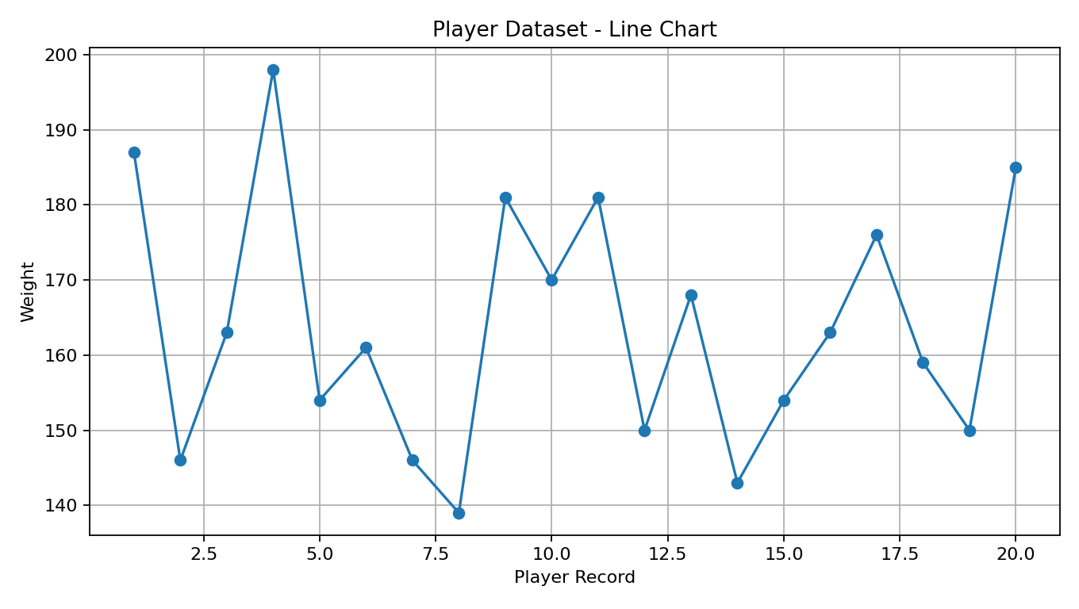
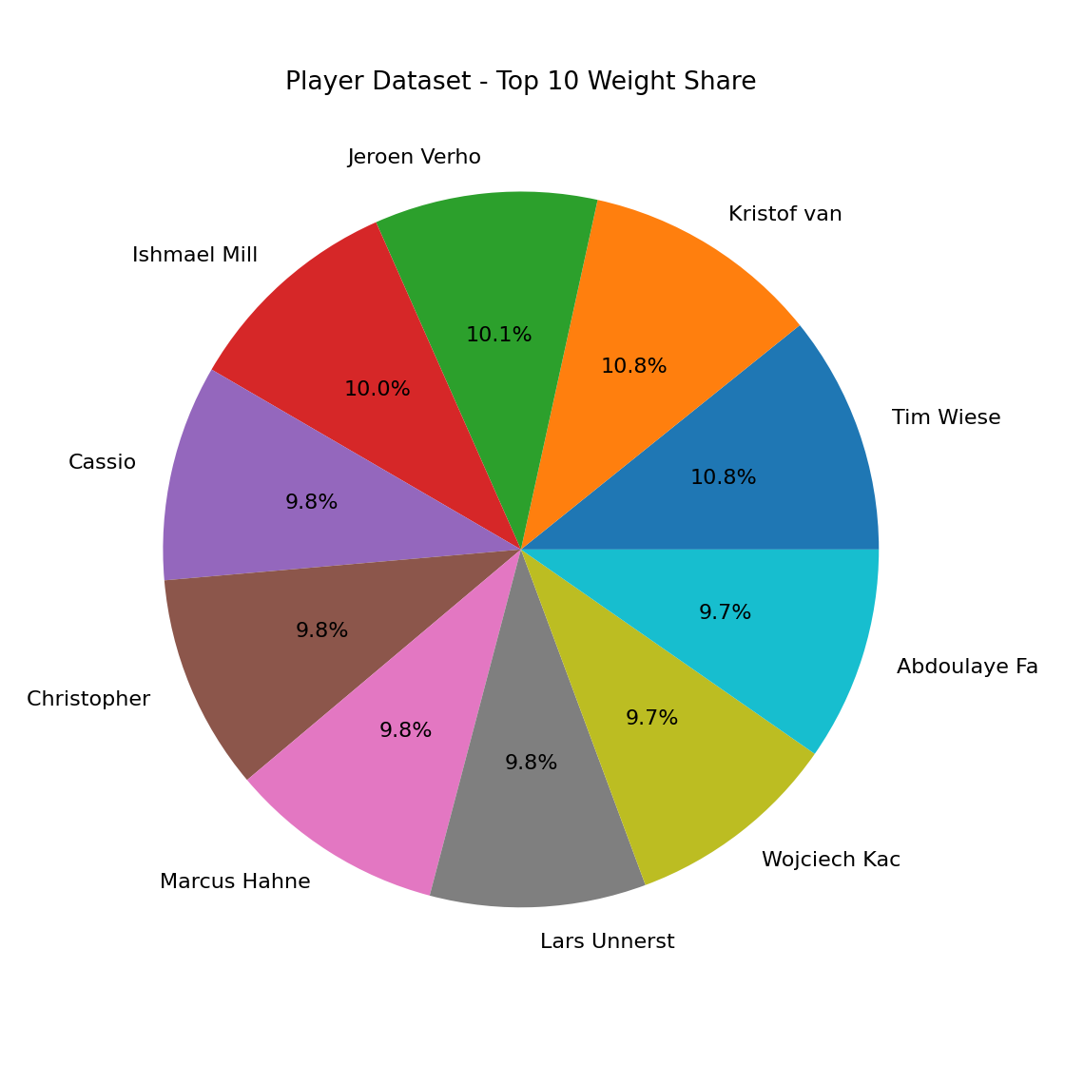
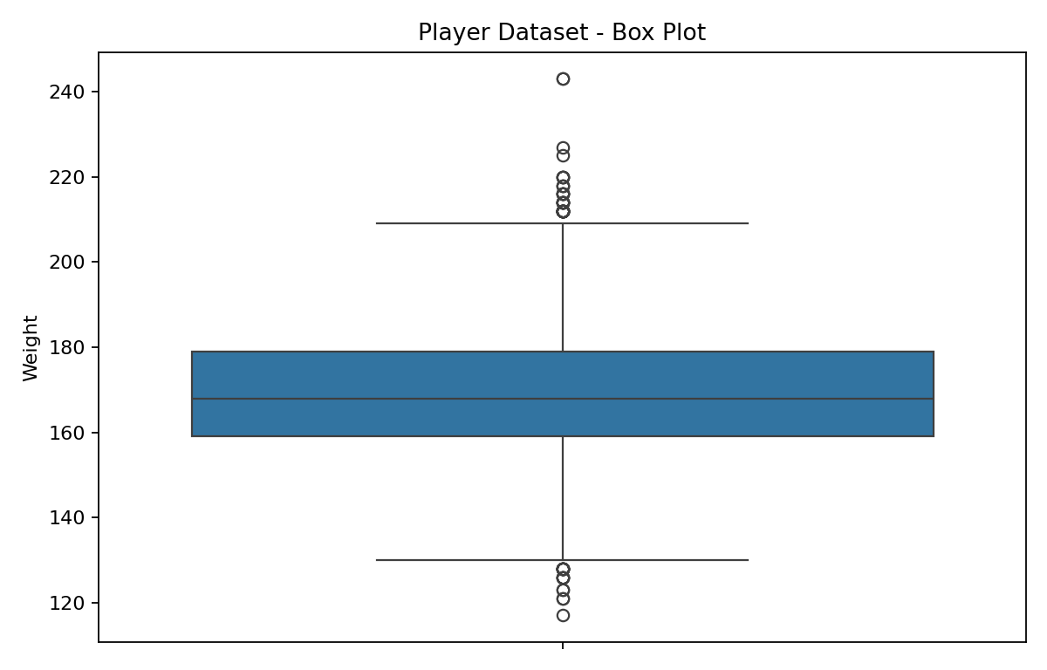
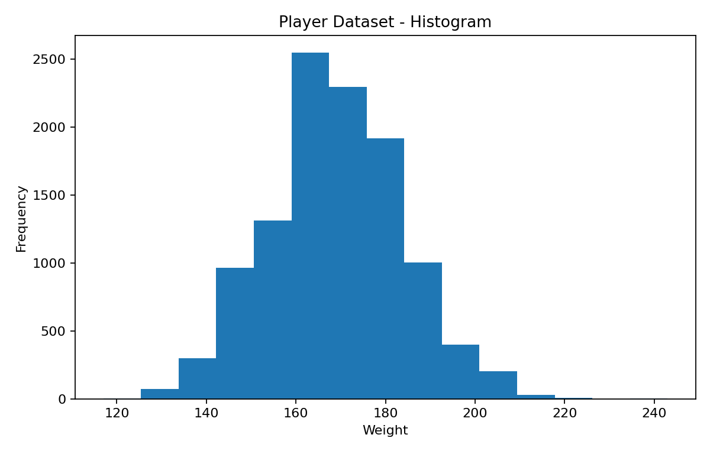
Result:
The Player dataset was successfully visualized using bar, line, pie, box, and histogram charts. The visualizations helped to understand player weight distribution, compare players, and identify important patterns and possible outliers.

